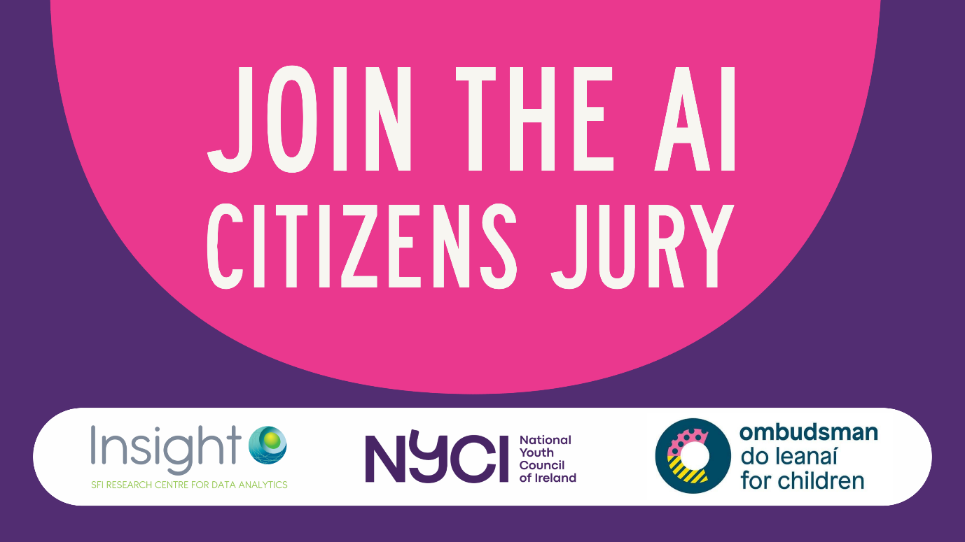
Alot is happening around AI; it is important young people are at the centre of that conversation.
📅 A Saturday in Nov
⏰10:00 – 17:00
📍Dublin City (Costs covered)
We are calling on all young people aged 13 - 22 to join our AI youth Juries. We have 6 juries that will meet on different topics and issues that are important to young people.

If selected you will meet with 7 other young people to discuss a key issue on Artificail intelligence, interview experts and formulate recommendations for policy makers.

You don't have to have any previous knowledge of AI, in fact that is preferable! There is no questions or application form, simply input your contact details and some demographic information; we then use a code to randomly select participants that are representative of the wider youth population.

Share the word
If you want to share this opportunity with others you can do so with the resources in our promo pack here!



